GCSE MUSIC – Key Terminology

In this booklet are some of the main key terms you need to know and be able to apply appropriately in the Listening and Appraising Exam.

You may know some already and some will be new. Write a definition next to each word – you may have to look the words up if you’re not sure and please make sure you have the correct musical definition!

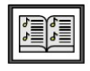
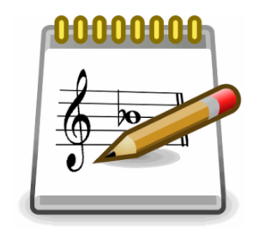
Extension activity: Find examples of the musical term in use and add it to the definition.
20th Century
Accidentals
Alberti Bass
Anacrusis
Arpeggio
Atonality
Augmented
Augmented 4th
Baroque
Basso Continuo
Cadences
Cadenza
Canon
Chaal (Fusion)
Chorale
Classical
Colla voce
Common time
Conjunct Movement
Contrapuntal
Contrast
Counterpoint
Cross-rhythms
Cut common
Declamatory writing
Delay (EDM)
Dhol (Fusion)
Diatonic
Diminished
Diminished 5th
Disjunct Movement
Dissonant
Dominant
Ensemble
Falsetto
Front line (Jazz)
Giddha (Fusion)
Harmonic Minor
Head (Jazz)
Hemiola
Homophonic
Imitation
Improvisation
Instrumentation
Interval
Inversion
Kicks and Licks (Jazz)
Lead sheet (Jazz)
Leitmotif
Looping (EDM)
Lower auxiliary note
Melodic Minor
MIDI
Modulation
Monophonic
Neapolitan chord
Nickelodeon
Ornamentation
Panning (EDM)
Parallel Movement
Pedal note
Pentatonic
Phasing (EDM)
Pivot chord
Polyphonic
Power chords
Range
Recitative
Remixing (EDM)
Renaissance
Repetition
Reverb (EDM)
Romantic
Sequence
Sforzando
Shout chorus (Jazz)
Skiffle
Sonata Form
Song Cycle
Staccato
Standard (Jazz)
Stop time (Jazz)
Storyboard
Suspension
Swing style
Syncopation
Texture
Timpani
Tonic
Transposition
Transverse Flute
Trill
Tritone
Tumbi (Fusion)
Turnaround (Jazz)
Unison
Variation
Virtuoso
Walking Bass

