Huxlow Academy Geography Department
OCR A GCSE Geography (9-1) Paper 1: Living in the UK Today Retrieval Booklet
Summer 2023
Use the Revision sheets (on Go4Schools) to help you recall information from Paper 1 and answer the questions contained in this booklet.

Contents:
- Unit 1: Landscapes of the UK
- Unit 2: People of the UK
- Unit 3: UK Environmental Challenges

Name: _________________________________________________

Retrieval Questions Landscapes of the UK
Key idea 1 - The physical landscapes of the UK have distinctive characteristics: | Responses
Describe the Distribution of Lowland, Upland and Glaciated landscapes.

Key idea 2 - Characteristics of these landscapes:
Describe the Geology, Climate & Human Activity of Upland, Lowland and Glaciated areas | Upland Lowland Glaciated  Geology  Climate  Human activity
Key idea 3 - Geomorphic processes create distinctive landscapes
Describe and explain the 3 types of Weathering: Mechanical, Chemical& Biological | Mechanical Chemical Biological  Describe Describe Describe  Explain Explain Explain
Describe the difference between 2 types of Mass Movement – Sliding and Slumping use diagrams | Slumping Sliding
Explain why Sliding and Slumping occur
Describe what Erosion is and how the processes of erosion operate: Abrasion, Hydraulic Action, Attrition & Solution | Erosion means………  Methods of Erosion  Abrasion Hydraulic action Attrition Solution
Describe what Transportation is and how the processes of Transportation operate: Traction, saltation, Suspension & Solution | Transportation means………  Methods of Transportation  Traction Saltation Suspension Solution
What is Deposition is and how does it work?
In Purple pen
Using these key areas, which area have you identified that you need to improve upon and why? – Knowledge not revising, misunderstanding etc…

Retrieval Questions Landscapes of the UK
Key idea 4
How rivers create landforms that change from source mouth in a drainage basin
Describe and explain how a Waterfall forms using diagrams
Describe and explain how a Gorge forms using diagrams
Describe and explain how an Ox–Bow lake forms using diagrams
Describe and explain how a Levee forms using diagrams
Key idea 5
Landforms within the Coastal landscape
Describe and explain how a Headland and Bay form using diagrams
Describe and explain how a Cave, Arch, Stack & Stump form at a Headland using diagram
Describe and explain how a Spit forms using diagrams
Key idea 6 – Case Studies
Landscapes are dynamic and differ depending on their Geology, Climate & Human activity
UK River Basin – For a named UK river basin you have studied
Describe and explain how geomorphic processes operate at different scales, being influenced by Geology and Climate
List the key landform features associated with the case study
Describe and explain how human activity, including management, works in combination with geomorphic processes to impact the landscape
UK Coastal landscape – For a named stretch of coastline you have studied
Describe and explain how geomorphic processes operate at different scales, being influenced by Geology and Climate
Describe the landform features associated with the case study
Describe and explain how human activity, including management, works in combination with geomorphic processes to impact the landscape
In Purple pen
Using these key areas which area have you identifed that you need to improve upon and why? – Knowledge not revising, misunderstanding etc…

Key ideas and content | Retrieval Questions: People of the UK
Key idea 1 – The UK is connected to many other countries and places
Describe what the word trade means
Describe who the UK trades with (Our major trading partners) EU - Especially Germany, France & USA, China etc.
Describe what the words Imports and Export means means
Describe what the UK’s main exports are and who we export to
Describe what the UK’s main imports are and who we import from
Key idea 2 – The UK is a diverse and unequal society which has Geographical patterns
Describe and explain UK patterns of:
Employment, Average Income, Life expectancy, Educational attainment, Ethnicity and Access to broadband
Key idea 3 – There are different causes and consequences of development in the UK
Describe the uneven level of development in the UK -Location – North / South divide – South East wealth
Describe the uneven level of development in the UK –
Economic change
Describe the uneven level of development in the UK –
Government policy
Key idea 4 – The UK’s Population is changing
What is the Demographic Transition model (DTM)? | 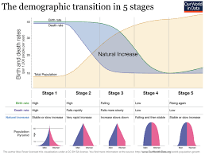
Describe the UK population 1900 to present day
Use the DTM and place the UK on different stages at different times from 1900 onwards
Describe and explain the causes of an Ageing population
Describe and explain the effects of an Ageing population
Describe and explain the responses to an Ageing population
What is immigration ?
What are Push and Pull factors?
Describe flows of immigration into the UK in the 21st Century (2000 onwards) – EU migrants & Refugees
Discuss the positive and negative Social and Economic aspects of this immigration | Social Economic
Key idea 5 – There are causes for and consequences of Urban trends in the UK
What is Suburbanisation?
Describe and explain the causes of Suburbanisation
Describe the Social aspects of Suburbanisation
Describe the Economic aspects of Suburbanisation
Describe the Environmental aspects of Suburbanisation
What is Counter urbanisation?
Describe and explain the causes of Counter urbanisation
Describe the Social aspects of Counter urbanisation
Describe the Economic aspects of Counter urbanisation
Describe the Environmental aspects of Counter urbanisation
What is Re urbanisation ?
Describe and explain the causes of Re urbanisation
Describe and explain the causes of Re urbanisation
Describe the Social aspects of Re urbanisation
Describe the Economic aspects of Re urbanisation
CASE STUDY - LEEDS
Describe and explain the influence of Leeds within the West Yorkshire region
Describe and explain the influence of Leeds within the UK
Describe and explain the influence of Leeds within the Wider world
Describe and explain the impact of national migration on Leeds growth and character
Describe and explain the impact of international migration on Leeds growth and character
Describe and explain the way of life in Leeds including Culture
Describe and explain the way of life in Leeds including Ethnicity
Describe and explain the way of life in Leeds including Housing
Describe and explain the way of life in Leeds including Leisure
I can describe and explain the way of life in Leeds including Consumption
I can describe and explain the challenges facing Leeds including Housing availability
I can describe and explain the challenges facing Leeds including Transport provision
I can describe and explain the challenges facing Leeds including Waste management
Leeds South Bank a Sustainable development

Retrieval Questions: UK Environmental Challenges
Key idea 1 – The UK has a unique climate for its latitude which can create extreme weather conditions | Responses
What is an air mass?
What is the North Atlantic drift and where is it? | 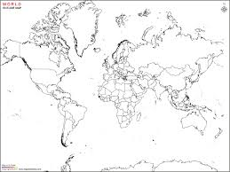
Describe and explain how land and water heat up and cool down
Describe and explain how Air masses, the North Atlantic drift and land mass influence weather in the UK
What is precipitation?
Describe and explain how air masses cause extremes of Wind in the UK
Describe and explain how air masses cause extremes of Precipitation in the UK
Describe and explain how air masses cause extremes of Temperature in the UK
Key idea 2 – Extreme flood hazard events are becoming more common place in the UK

CASE STUDY – Flood event – Caused by extreme weather Somerset levels
Where are the Somerset levels?  Mark them on with an X  And then say why the landscape is unique. | 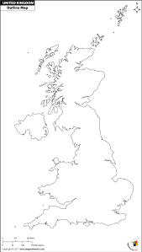
Describe the Physical and Human causes of the event | Physical causes of the Somerset levels flood event of January 2014 Human causes of the Somerset levels flood event of January2014
Describe and explain the effects of the flood upon the Social (People), Economic (Money) and Environmental (the Landscape) aspects | Social Economic Environmental
Describe and explain the responses and management to the flood event

What did they do initially and what ddi they do to stop it happening again in the future?
In Purple pen
Using these key areas which area have you identifed that you need to improve upon and why? – Knowledge not revising, misunderstanding etc…

Key idea 3 - Humans use, modify and change ecosystems and environments to obtain Food, Energy and Water

What is an ecosystem?
Explain how the environment / ecosystems are modified / changed by Wind Farms to provide energy | 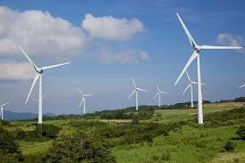
Explain how the environment / ecosystems are modified / changed by Fracking to provide energy | 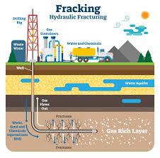
Explain how the environment / ecosystems are modified / changed by reservoirs and water transfer schemes to provide drinking water | 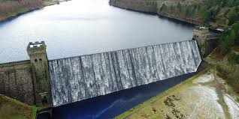
Explain how the environment / ecosystems are modified / changed by the mechanisation of farming to produce food | 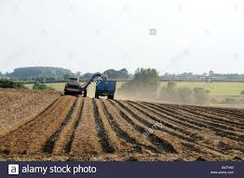
Explain how the environment / ecosystems are modified / changed by commercial fishing to produce food | 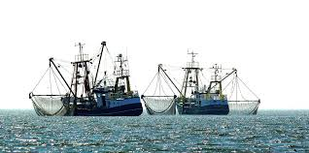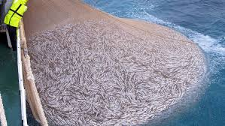
Key idea 4 – There are a range of energy sources available to the UK

What renewable energy resources?
Name some
What are non - renewable energy resources?
Name some
What is the energy mix?
Describe and explain the contribution of renewable and non-renewable energy sources to energy supply in the UK | 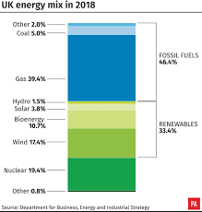
Key idea 5 – Energy in the UK is affected by a number of factors and requires careful management and consideration of future supplies
What is energy demand?
What is energy supply ?
Describe and explain the change in patterns in energy demand and supply from the 1950’s to present day caused by Government decisions
Describe and explain the change in patterns in energy demand and supply from the 1950’s to present day caused by International organisations
What does the word sustainable mean?
Describe and explain strategies for sustainable energy use
Anaerobic digestion Silloth Cumbria
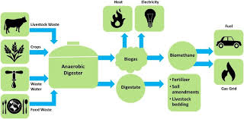

Carbon capture and and storage
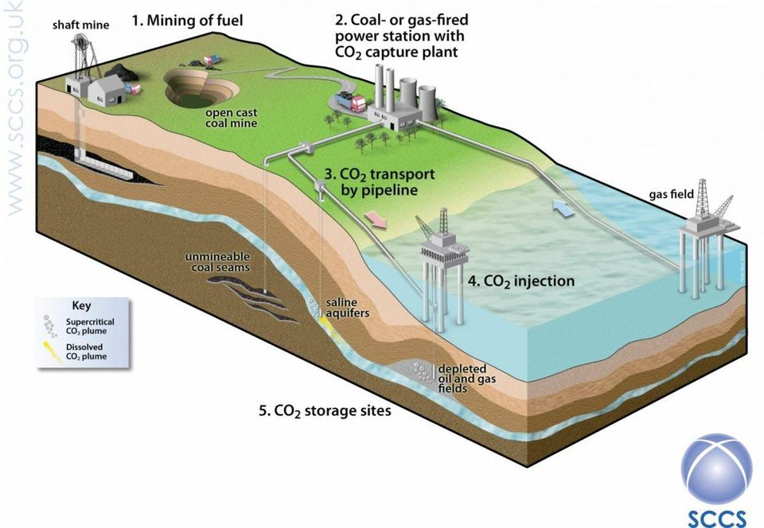

Describe and explain these strategies and their management at a local and national level and describe their level of success

Describe and explain the development of renewable energy in the UK

Describe and explain why renewable energy should contribute to the UK’s energy supply

Describe and explain the Economic, Political and Environmental factors affecting UK energy supply in the future
Economic | Political | Environmental

In Purple pen
Using these key areas which area have you identified that you need to improve upon and why? – Knowledge not revising, misunderstanding etc…

